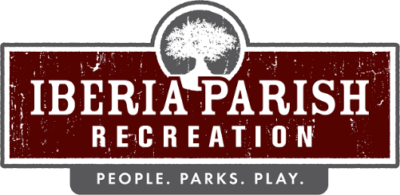

Agenda for the scheduled regular board meeting of the IBERIA PARISH RECREATION AND PLAYGROUND COMMISSION to be held on TUESDAY, MARCH 10, 2026 at 6:15 PM in the Meeting Room at the Administrative Office located at Willow Wood Park, 113 Willow Wood Drive, New Iberia, LA.

1. Opening Prayer.

2. Call to order.

3. Roll call.

4. Persons to address the board – 3 minutes/person.

5. Consider a motion to approve the minutes of the regular scheduled board meeting held on February 10, 2026, as published and take appropriate action.

6. Receive an update on ongoing projects and take appropriate action.

7. Announcements.
1. Sales Tax Collection for the month of February 2026
2. Recap of 2026 Sales Tax Collections
3. Reminder of Mandatory 2026 Ethics and Sexual Harassment
4. New Iberia Garden Club will be planting the donated Oak Tree at the Isle of Iberia, on March 17th, weather permitting. Board members are invited to attend.
5. Upcoming Community Co-sponsored Easter Egg Hunts and activities
a. Ward 8 Recreation- Saturday, March 21st, starts at 11am - Bunny Hop Skating Bash & Easter Egg Hunt
b. Loreauville Park- Sunday, March 22nd starts at noon (Loreauville Community Project) – Easter Egg Hunt
c. Coteau Park - Saturday, March 28th, 1pm-4pm (Krewe Du Coteau) - 2026 Easter Eggtravaganza

8. Correspondence.
1. Email from Carrie Terry, Clerk of the Council, requesting Director’s attendance at the Wednesday, March 11, 2026 Iberia Parish Council Meeting.

9. Adjournment.

