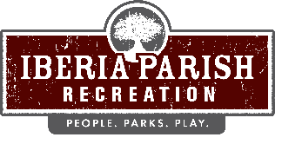

Agenda for the scheduled regular board meeting of the IBERIA PARISH RECREATION AND PLAYGROUND COMMISSION to be held on TUESDAY, FEBRUARY 10, 2026 at 6:15 PM in the Meeting Room at the Administrative Office located at Willow Wood Park, 113 Willow Wood Drive, New Iberia, LA.
- Opening Prayer.

- Call to order.

- Roll call.

- Persons to address the board – 3 minutes/person.

- Consider a motion to approve the minutes of the regular scheduled board meeting held on January 13, 2026 as published and take appropriate action.

- Consider a request from Iberia Parish Government to rename the Loreauville Park, located at 601 Ed Broussard Road, Loreauville, Louisiana in honor of Mr. Glenn P. Romero, Sr. in recognition of his 28 years of dedicated public service to his community. The park would be named Glenn P. Romero, Sr. Memorial Park and take appropriate action.

- Consider a request from the New Iberia Garden Club for the Iberia Parish Recreation and Playground Commission to plant another live oak tree at the Isle of Iberia in honor of Arbor Day in February and take appropriate action.

- Receive an update on ongoing projects.

- Announcements.
- Sales Tax Collection for the month of January 2026
- Recap of 2026 Sales Tax Collections

10. Correspondence.

11. Adjournment.

113 Willow Wood Drive, New Iberia, LA 70563 Phone: 337-365-6197 Fax: 337-369-4470

