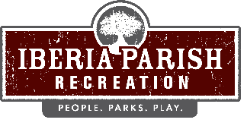

Agenda for the scheduled regular board meeting of the IBERIA PARISH RECREATION AND PLAYGROUND COMMISSION to be held on TUESDAY, MAY 12, 2026 at 6:15 PM in the Meeting Room at the Administrative Office located at Willow Wood Park, 113 Willow Wood Drive, New Iberia, LA.

- Opening Prayer.

- Call to order.

- Roll call.

- A.Persons to address the board – 3 minutes/person.

- Consider a motion to approve the minutes of the regular scheduled board meeting held on April 14, 2026, as published and take appropriate action.

- Consider a request to authorize the Chairman of the Iberia Parish Recreation and Playground Commission to execute a Lease Agreement between the Congregation of Our Lady of Prompt Succor Roman Catholic Church, as Lessor, the Iberia Parish Recreation and Playground Commission and the Iberia Parish Government as Lessee and take appropriate action.

- Discuss and receive an update on Capital Improvement Projects and take appropriate action.

- Discuss building capacity of rentals and take appropriate action.

- Discuss and consider the public’s use of inflatables on park grounds and take appropriate action.

- Announcements.
- Sales Tax Collection for the month of April 2026
- Recap of 2026 Sales Tax Collections
- Reminder of Mandatory 2026 Ethics and Sexual Harassment

- Correspondence.

- Adjournment.

